Fast pay Integration Ui Enhancements

CLIENT SIDE
- Make a new variable “isPayemntDue” in invoices if it is true show Payment Due Column in the table and via clicking on it redirect client to payment gateway (Fast pay)
- Along with pay now button show pay all button with will help client to pay for all employees in one go
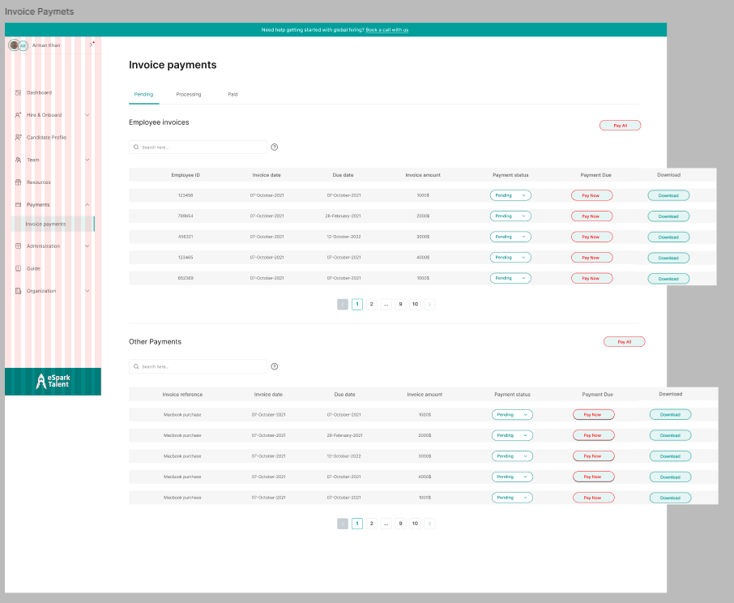

- Must show Pay now on each employee profile as well into Team member page
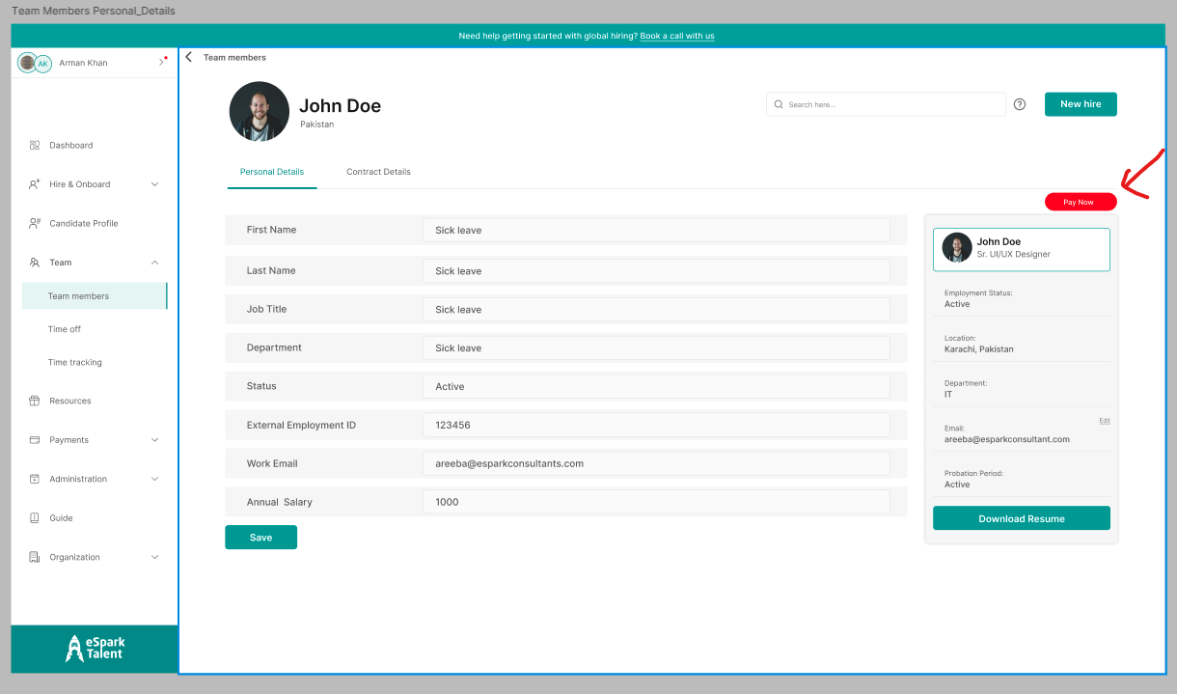
- Optional on all members page and Time out pages as well e.g.
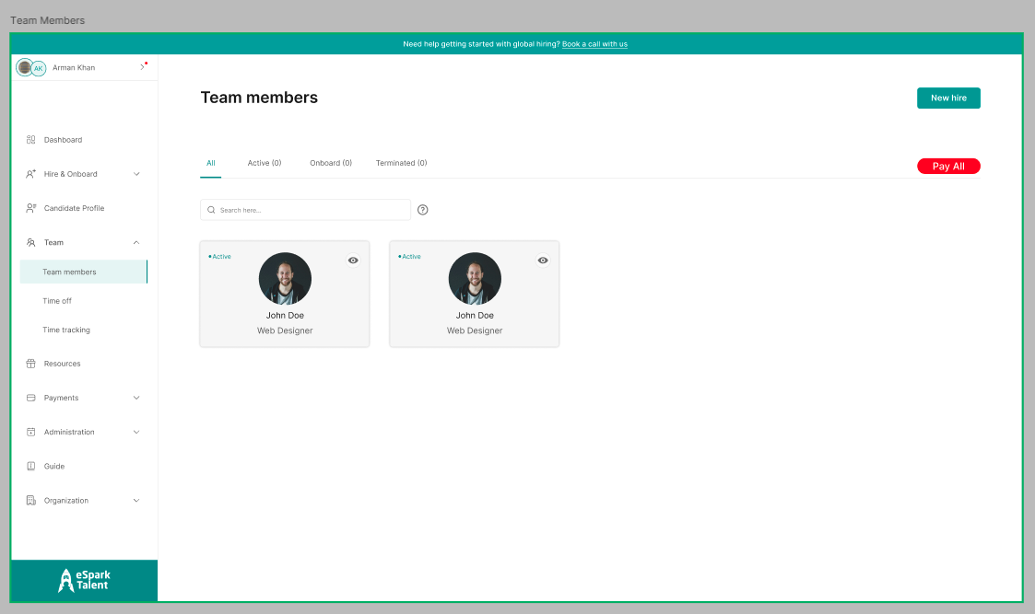
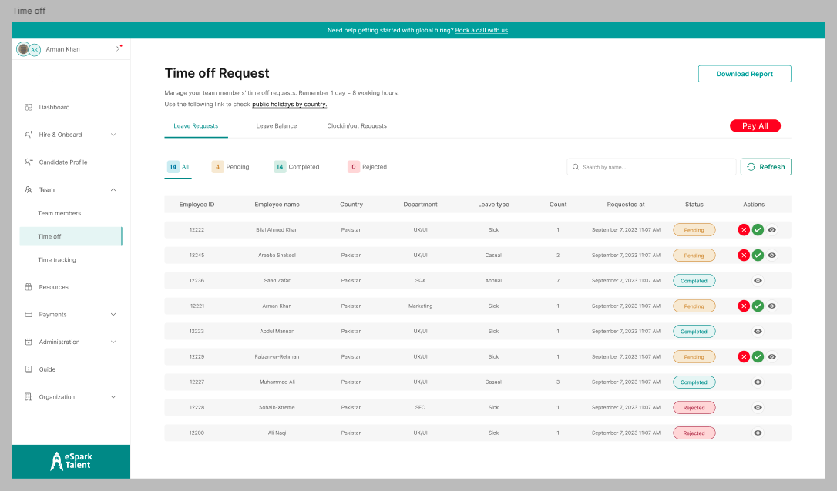
PAYOUT SCREEN:
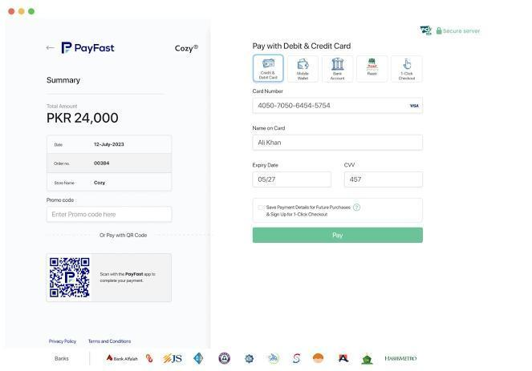

HR SIDE
- In Invoice Section Other Invoices is add able for each Client & employees invoices Must be automated (according to due date set in each client profile or Set it to default end of the month)
- BE SIDE: emp_invoice: CREATE & DELETE will be removed only GET remains
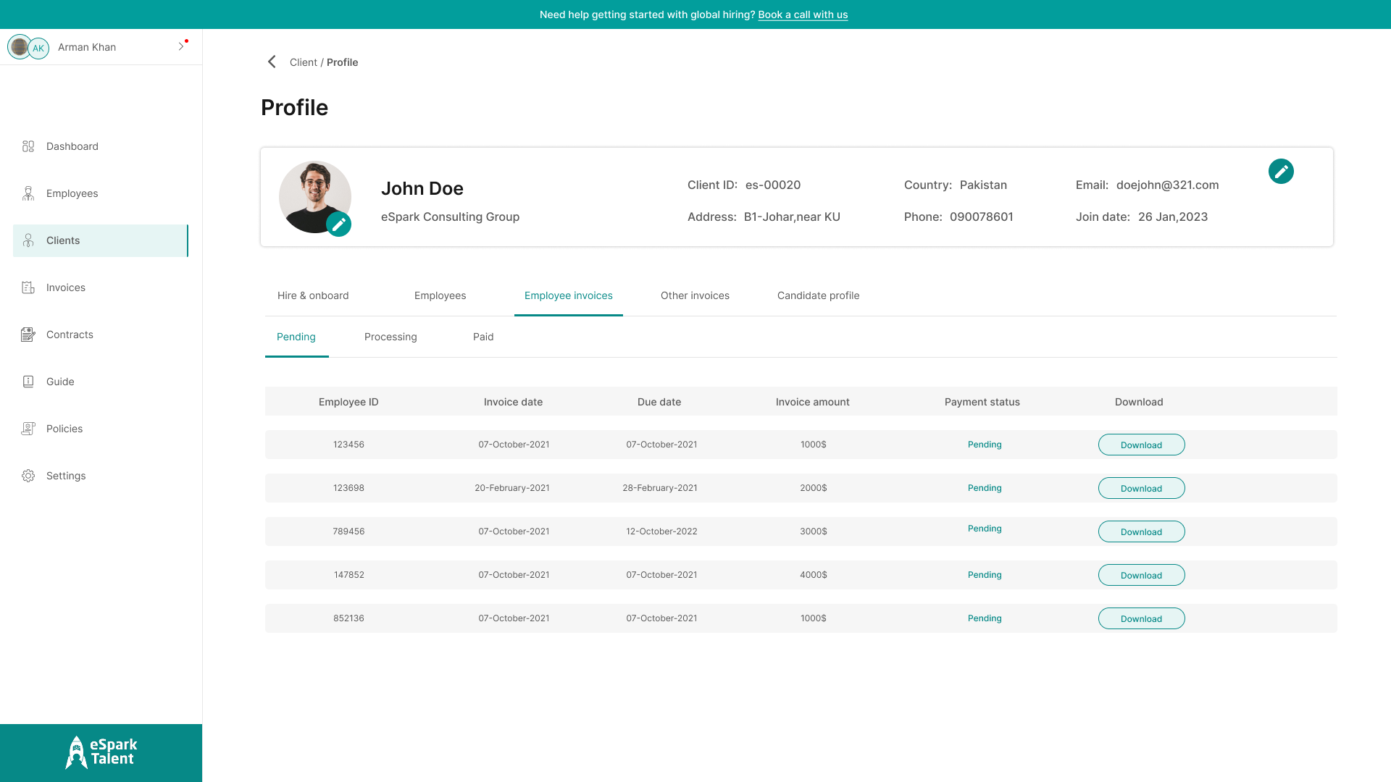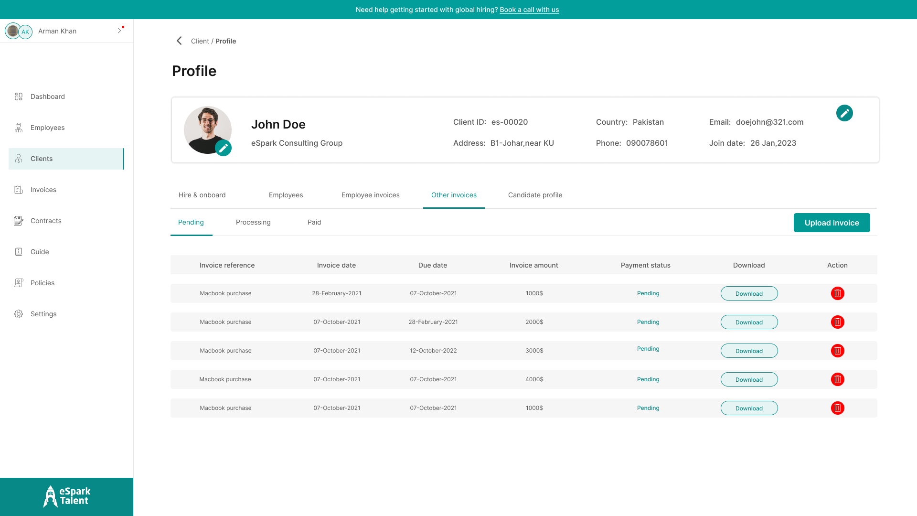

- Date of invoicing Example (must be added this inputs into create & edit Client Info)
- 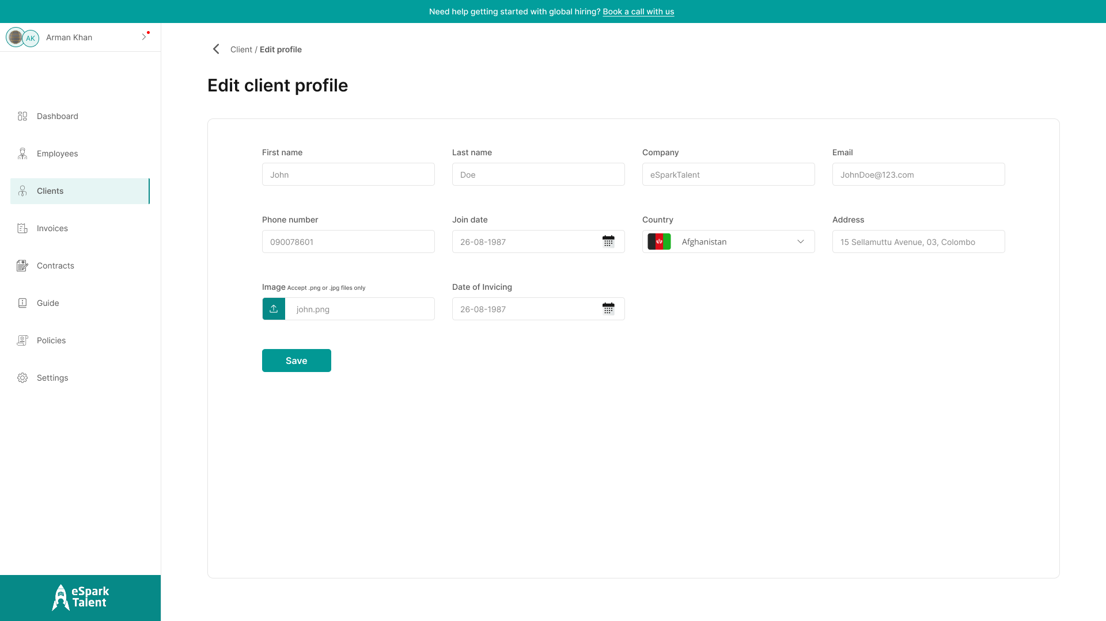
NOTIFICATIONS Changes:
- as soon as Salary Invoice auto generates send message to client & HR,
For Client & HR: Salary Invoice is issued against employee: “{emp_name}” for the month of {jan-2026}
other Invoices notification (only go to client): a new Invoice is issued by HR {other_invoice_name/ID}
OTHER UI REALTED ISSUES:
In Employee Creation
Instead of getting company name statically get exiting Companies name (Dropdown needed)
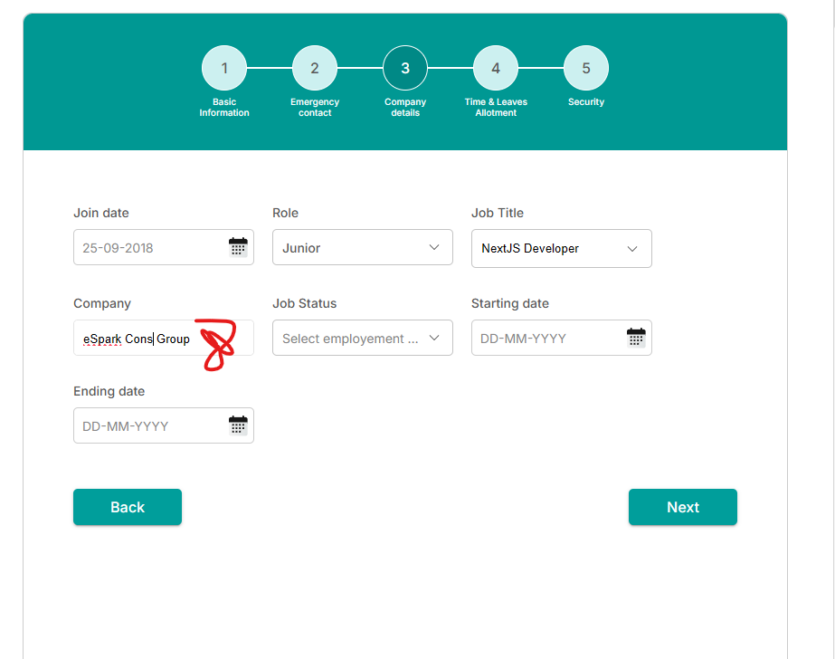
Here Need direct input option as well (issue: its take time to add it via counter ++ 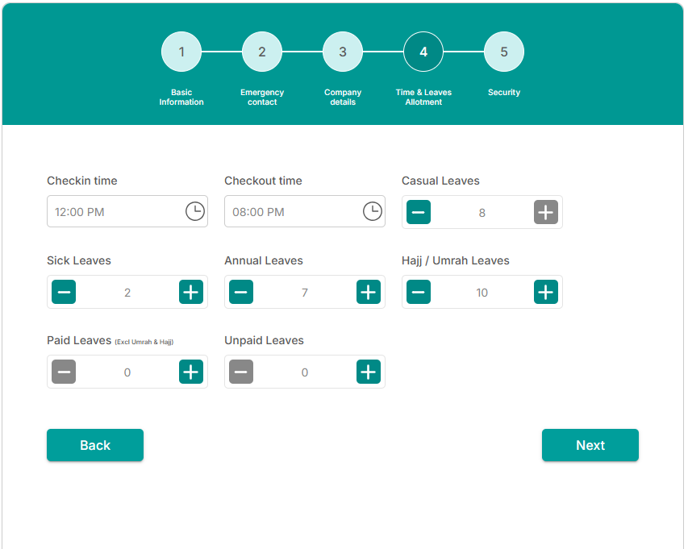
Optional Screen (its depend on what we are managing Payments api from env for HR side)
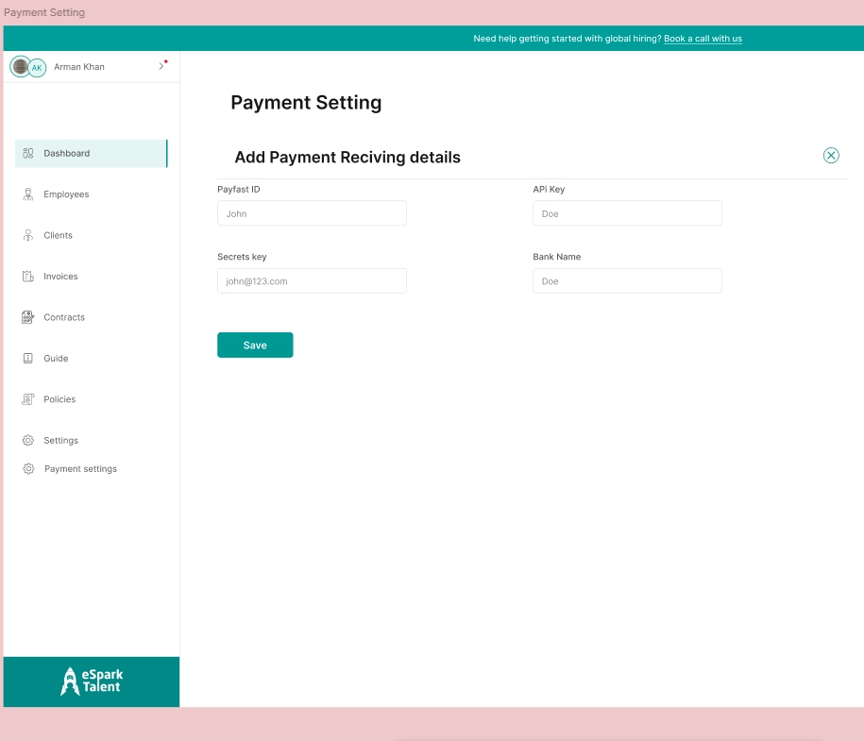

Backend Guides

PayFast + Auto Invoice Enablement https://gopayfast.com/docs/#apps-go-cashless
Core Concept (No Change to Existing Dashboards)
You already have:
- Employees
- Clients
- HR dashboard
We are only adding:
- PayFast enablement
- Invoice automation (employee + client)
- Bulk & custom payment handling
No dashboard rewrite
No manual salary invoice creation from HR
Fully automated + compliant

Invoice Model Enhancements (Minimal)
invoices table (need to add only these fields)
ALTER TABLE invoices ADD COLUMN is_payment_due BOOLEAN DEFAULT true;
ALTER TABLE invoices ADD COLUMN invoice_type ENUM('SALARY','CLIENT_CUSTOM') NOT NULL;
ALTER TABLE invoices ADD COLUMN employee_id UUID NULL;
ALTER TABLE invoices ADD COLUMN billing_month DATE;
ALTER TABLE invoices ADD COLUMN basket_id VARCHAR UNIQUE;
Rules
- basket_id = invoice_id (PayFast mandatory)
- SALARY → auto-generated (employee-based)
- CLIENT_CUSTOM_INVOICES → HR-generated
Employee Salary Invoice Automation (BE ONLY)
🔄 Cron Job (Monthly)
0 2 1 * *
Logic
for each ACTIVE_EMPLOYEE:
if employee.client.active:
generate invoice:
- employee_id
- client_id
- amount = salary
- billing_month = current month
- invoice_type = SALARY
- is_payment_due = true
HR cannot CREATE / DELETE salary invoices
HR can VIEW only Invoices
UPDATE APIS (BE)
REMOVE these methods
- POST /hr/employee-invoices
- DELETE /hr/employee-invoices
Client-Side Payment Enablement (Fast Pay)
UI Flag (Backend Driven)
Invoice initial date
{
"invoice_id": "INV-2026-001",
"is_payment_due": true
}
Behavior
UI Element | Condition
Payment Due column | is_payment_due === true
Pay Now (per employee) | Single invoice
Pay All | Multiple invoices (bulk)

Bulk Payment (IMPORTANT)
Frontend sends:
{
"invoice_ids": ["INV-1", "INV-2", "INV-3"]
}
Backend:
- Validate all invoices belong to same client
- Create ONE PayFast transaction
- Generate Master Invoice
- Link all child invoices
Tables
bulk_payments
- id
- client_id
- total_amount
- transaction_id
Rule
Client pays once, system distributes internally
PayFast sees one basket (bulk Invoice)

PayFast Service (No Frontend Exposure)
Create function to enable PayFastService
class PayFastService {
getToken()
getBanks()
getInstruments(bankCode)
initiatePayment(basket)
checkStatus(basketId)
}
Token Rules
- Cache for 55 min
- Auto refresh
- Stored server-side only
Auto Due Date Logic
- Get Due Date from Client Profile:
  - Custom due date OR set Default: end of month
Notifications (Amendment & Automation)
Salary Invoice Generated
Client + HR
Salary Invoice is issued against employee {emp_name}
Billing month: Jan 2026
HR Custom Invoice
Client only
New invoice issued by HR Invoice ID: {INV-ID}
Triggers:
- Auto Salary Invoice creation (to both HR & Cleint)
- Custom Invoice creation (to Client only)
- Payment success (to HR only)
Employee Creation Fix/Optional (Backend)
Companies Dropdown
Create new endpoint to get all Client companies list
GET /companies
What You DON’T Need to Build Again
- Dashboards
- Employee logic
- Client logic
- HR permissions system
We are plugging PayFast + invoices cleanly into what already exists.
Final Outcome
- Clients pay per employee OR bulk
- HR manages custom invoices only
- Salary invoices are 100% automated
- PayFast compliant & scalable
- Stripe / Payoneer can be added later without refactor

